EXPERIMENT : 02

NAME : KISHORE.K ROLL NO : 240701267

Experiment: Memory Recall Task Interface Design
1. Aim
To design a Memory Recall Task interface that helps test and improve the user's memory and recall ability using a simple interactive application.

2. Objective
- To display a set of icons or text items to the user.
- To allow the user to observe the items for a limited time.
- To test whether the user can recall the items correctly.
- To provide feedback or rating based on the user's performance.

3. Tools Used
- UI design tool such as Figma
- Basic interface components (buttons, text, images, cards)
- Simple animation or timer features

4. Description of the Interface
4.1 Memory Recall Instruction Screen
This screen explains the task to the user before starting the test.
Features:
- Title “Memory Recall Task” displayed at the top.
- Instructions explaining how the task works.
- The user will see several groups of icons or text.
- After viewing them, the user must recall the items they remember.
- The user gets 5 seconds to observe the items before recalling.
- A Start button to begin the memory test.
Design Elements:
- Attractive sunset background to make the interface visually appealing.
- Clear instructions using bullet points.
- Simple layout so users can easily understand the task.
Purpose:
- To inform the user about the rules and steps of the memory test.

4.2 Result / Rating Screen
This screen appears after the user completes the recall task.
Features:
- Displays the performance rating of the user.
- Example shown: 4/5 rating based on how many items were remembered.
- Star rating to visually represent the performance.
- A “Congratulations” message to encourage the user.
Design Elements:
- A 3D character illustration to make the result screen engaging.
- Neon-style rating box highlighting the score.
- Dark theme background for better visual contrast.
Purpose:
- To show the user's memory performance.
- To motivate users to improve their memory skills.

5. Advantages
- Helps in improving memory and concentration.
- Simple and easy-to-understand interface.
- Interactive design increases user engagement.
- Instant feedback through ratings.

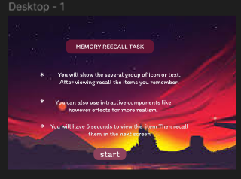

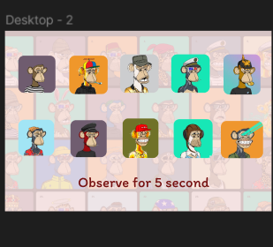

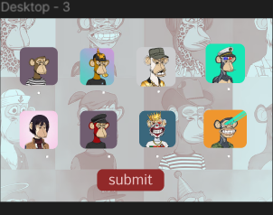



6. Result
The Memory Recall Task interface was successfully designed with an instruction screen and result screen, enabling users to test their memory and receive performance feedback in an engaging way.

LINK:

https://www.figma.com/design/bf2M3Q2TyQ1qgKhoDZbKbS/Untitled?node-id=0-1&t=E2C30i24ih4CdL6h-1

